**Constraints, DDL & DML**

**Query #1:** This query is used to make a connection.

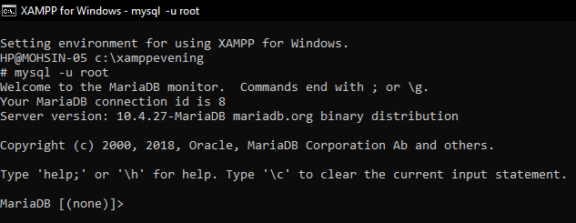

**Query #2:** Used to create a database.

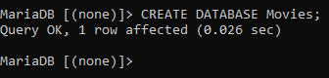

**Query #3:** Used to show all databases.

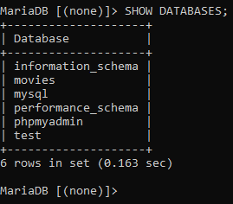

**Query #4:** Used to enter a database.



**Data Definition Language Queries**

**Query #5:** Creating a table and making a primary key that auto increments.

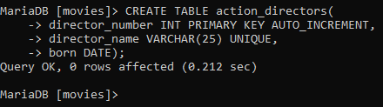

**Query #6:** Creating a table and making a foreign key, which is a primary key of another table.

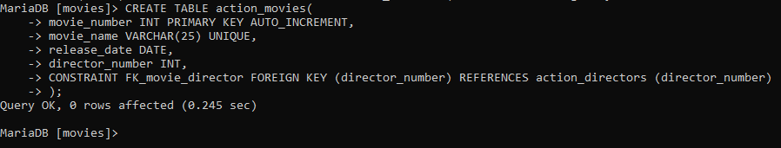

**Query #7:** Describing a table.

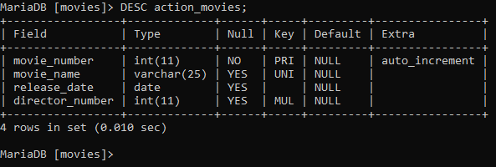

**Query #8:** Creating Foreign Key in another table.

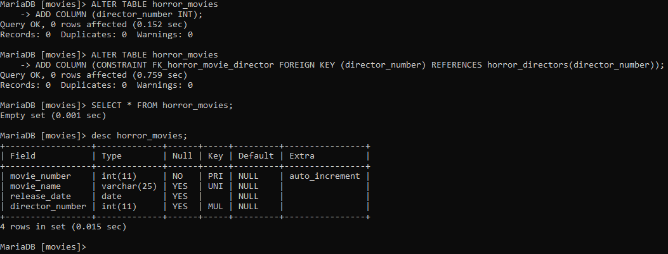

**Query #9:** Creating a Foreign Key while creating a table.

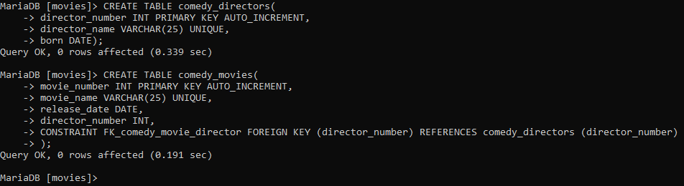

**Query #10:** Creating a Foreign Key in a created table.



**Query #11**: Creating a Foreign Key in a created table.

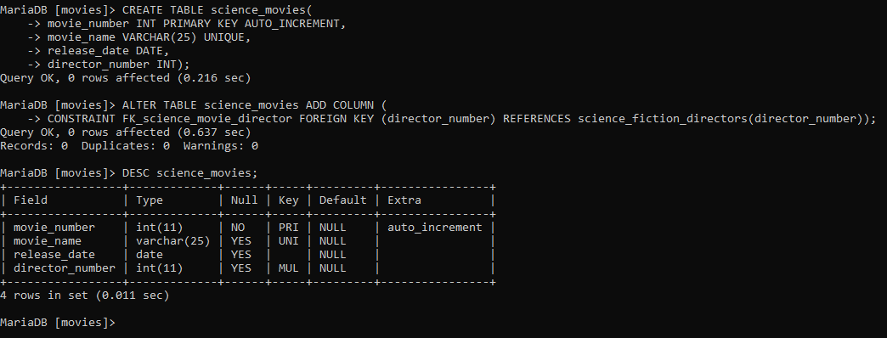

**Query #12:** Showing all the tables in a database.

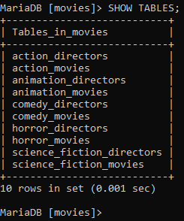

**Query #13:** Drop means deleting the entire table completely with data and structure.

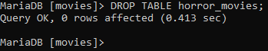

**Query #14**: Using ALTER TABLE to add a column in a table.

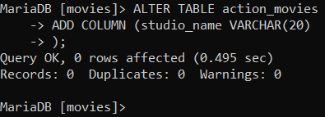

**Query #15:** Using ALTER TABLE to modify a column in a table.

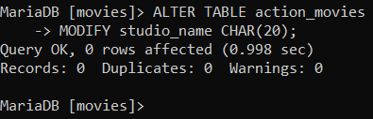

**Query #16:** Using ALTER TABLE to rename a table.

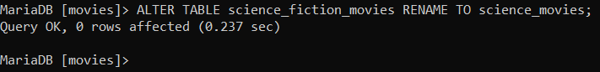

**Query #17:** Using ALTER TABLE to delete a column in a table.

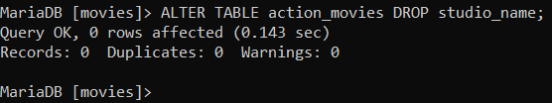

**Query #18:** Using ALTER TABLE to change a column name in a table.

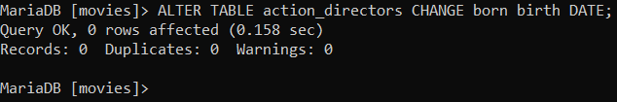

**Data Manipulation Language Queries**

**Query #19:** Inserting values in fields of a table.

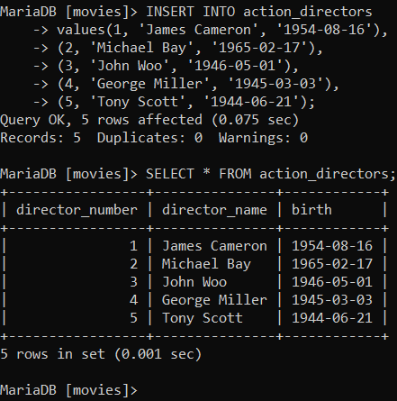

**Query #20:** Inserting values in specific fields of a table.

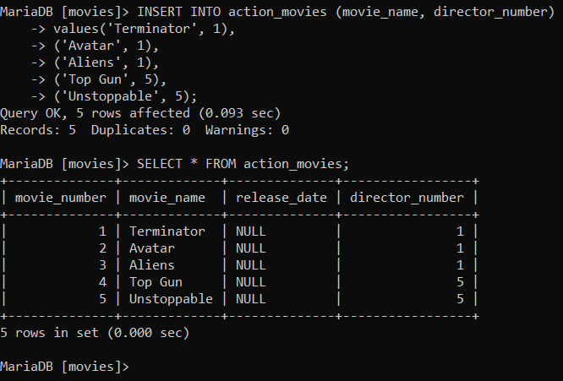

**Query #21:** Updating a table to change all values of a column.

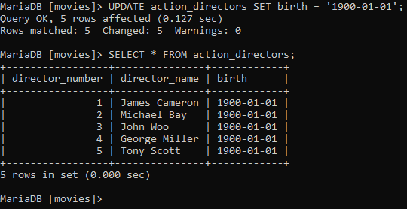

**Query #22:** Updating a table to change value of a specific field record.

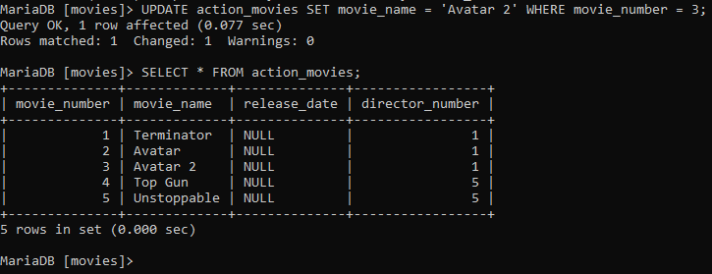

**Query #23:** Deleting a specific record.

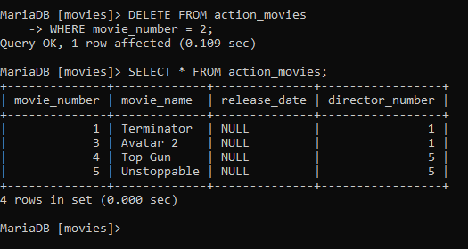

**Query #24:** Deleting all records from a table.

